Integration and Testing Report – Banking System
Objective
The purpose of this report is to verify the successful integration of all components of the banking system application. This includes the GUI boundary classes, controller classes, core domain model classes, and JDBC-based data access layer. The goal is to ensure that the system functions as a cohesive unit and supports realistic user workflows such as login, account creation, and transactions.
Test Scenarios
Scenario 1: Teller Creates New Customer and Account
- A teller enters customer details and account preferences to create account.
- There is a deposit requirement which when not meet a message is given.
- The controller calls CustomerDAO and AccountDAO to persist data.
- The GUI confirms success and updates the view.
Scenario 2: Customer Login and Dashboard Access
- A customer logs in using valid credentials.
- The controller verifies credentials via the JDBC CustomerDAO.
- The GUI transitions to the customer dashboard.
Scenario 3: Customer Performs Deposit
- A customer selects an account and enters a deposit amount.
- The controller updates the balance via AccountDAO.
- A transaction is logged via TransactionDAO.
Modules Integrated
The Banking System project successfully integrates four major components. First, the Boundary (GUI) layer is built using JavaFX and provides the user interface for both customers and tellers. It includes screens for login, dashboards, account management, and transaction operations. Second, the Controller classes act as intermediaries between the GUI and the business logic. They handle user actions such as button clicks, form submissions, and navigation, ensuring that the correct logic is triggered in response to user input.
Third, the Core Domain Model consists of classes like Customer, Account, and Transaction, which represent the main entities in the system. These classes encapsulate the business rules and data structures that define how the banking system operates. Finally, the JDBC Data Access classes manage all interactions with the SQLite database. These include CustomerDAO, AccountDAO, and TransactionDAO, which handle data retrieval, insertion, updates, and schema initialization.
Expectation vs Actual Results
Test Case | Description | Expected Output | Actual Output | Result
1. Customer Login | Valid credentials entered | Dashboard loads | Dashboard loads | Pass
2. Teller Login | Teller enters login credentials | Dashboard loads | Dashboard loads | Pass
3. Create Account | Account linked to new customer | Account saved in DB | Verified in DB | Pass
4. Deposit Funds | Customer deposits into account | Balance updated, transaction logged | Balance updated, transaction logged | Pass

Screenshot showing Teller login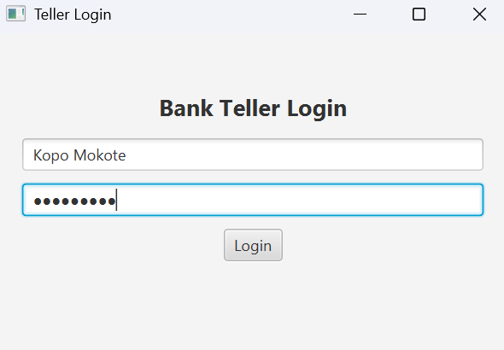

Screenshot showing account creating but the deposit amount is not enough so the account is not created
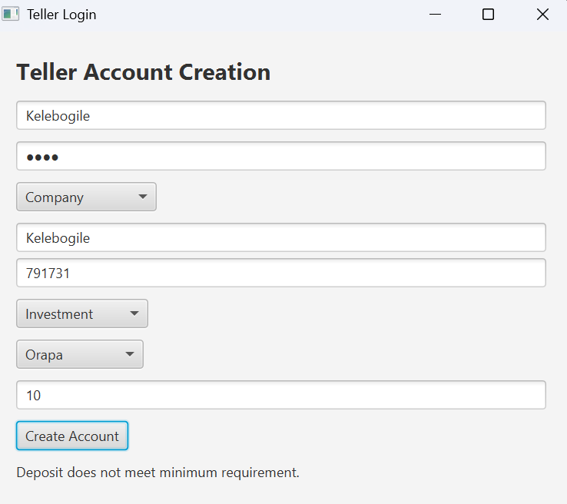

Screenshot showing successful account as the initial deposit is sufficient
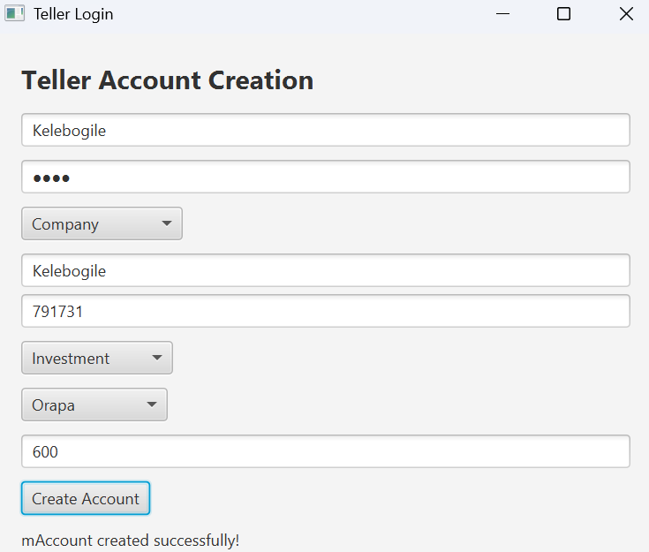
Screenshot showing customer login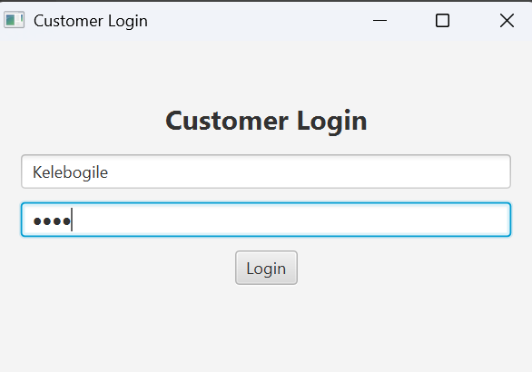

Screenshot showing customer view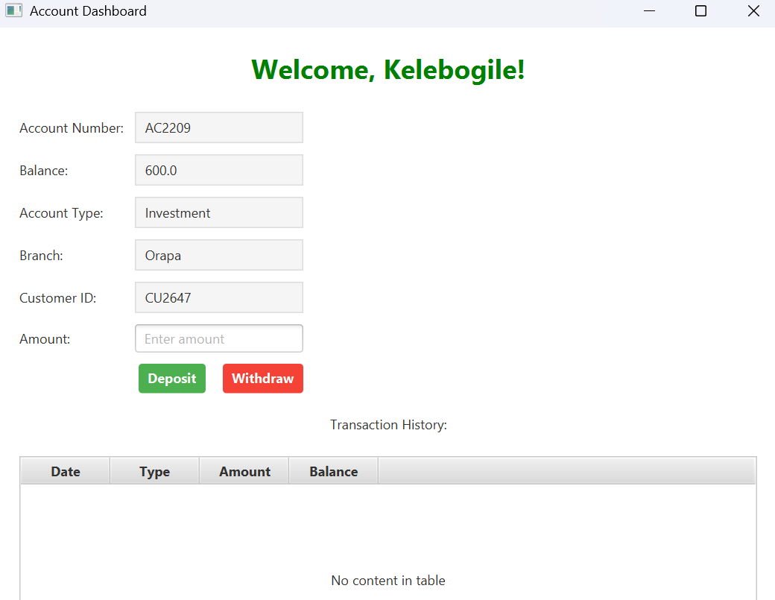

Screenshot showing successfull deposit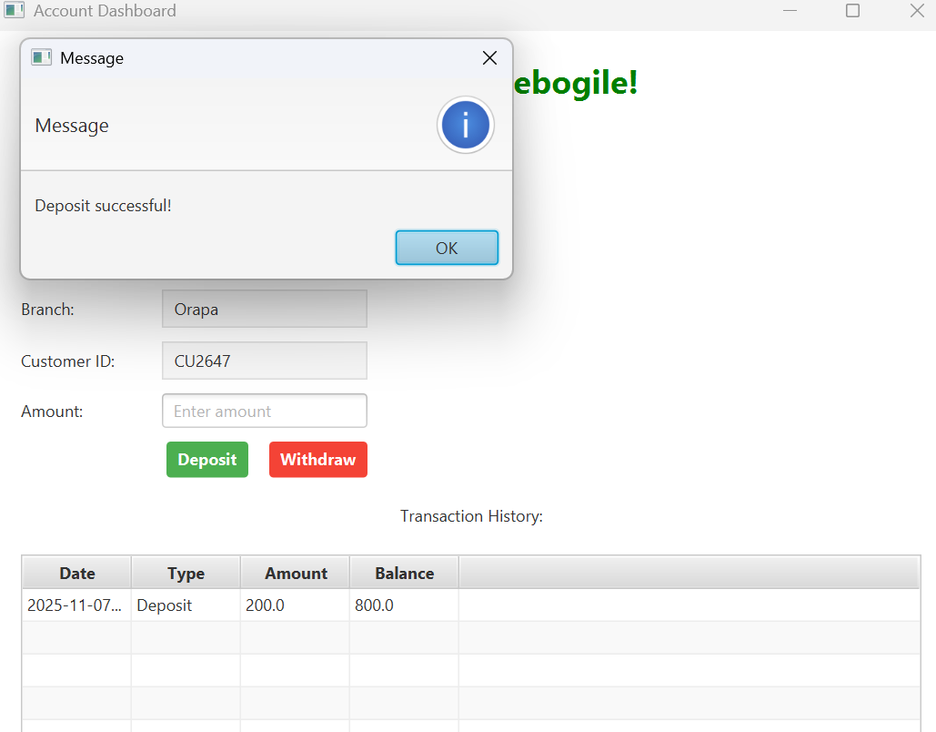

Screenshot showing successful withdrawal
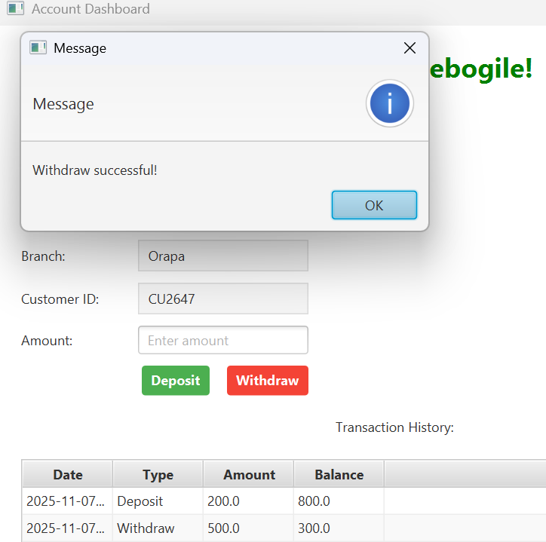
Conclusion
All components (GUI, Controller, Model, and JDBC) worked together as intended. Integration testing confirmed that realistic user flows such as login, account creation, and transactions work. The system is stable and functional.

